**Experiment 7**

**Student Name:** Sahil Kaundal **UID:** 21BCS8197

**Branch:** BE CSE (Lateral Entry) **Section/Group:** 807/B

**Semester:** 4th **Date of Performance:** 14/04/2022

**Subject Name:** MPI Lab **Subject Code:** 22E-20CSP-253

1. **Aim/Overview of the practical:**

Shifting of 16-bit numbers.

**2. Task to be done/ Which logistics used:**

a) Shift a 16-bit number to left by 1-bit

b) Shift a 16-bit number to left by 2-bits.

**3. Apparatus / Simulator Used:**

1. Jubin Application

2. 8085 Simulator

3. JDK

**4. Algorithms/Flowcharts:**

**Shift a 16 -bit number to left by 1-bit:**

1. Load H – L pair with address 3000H.

2. DAD is used to shift the 16-bit number to left by 1-bit.

3. Store HL pair using direct addressing in memory location.

4. Terminate the program.

**Shift a 16 -bit number to left by 2-bits:**

1. Load H – L pair with address 3000H.

2. DAD is used to shift the 16-bit number to left by 2-bits.

3. Store HL pair using direct addressing in memory location.

4. Terminate the program.

**5. Programs:**

**Shift a 16 -bit number to left by 1-bit:**

# BEGIN 0000H

LHLD 3000H

DAD H

SHLD 3001H

HLT

# ORG 3000

# DB 96H,75H

**Shift a 16 -bit number to left by 2-bits:**

# BEGIN 0000H

LHLD 3000

DAD H

DAD H

SHLD 3001

HLT

# ORG 3000

# DB 96H,75H

**6. Result/Output/Writing Summary:**

**a) Shift a 16 -bit number to left by 1-bit:**

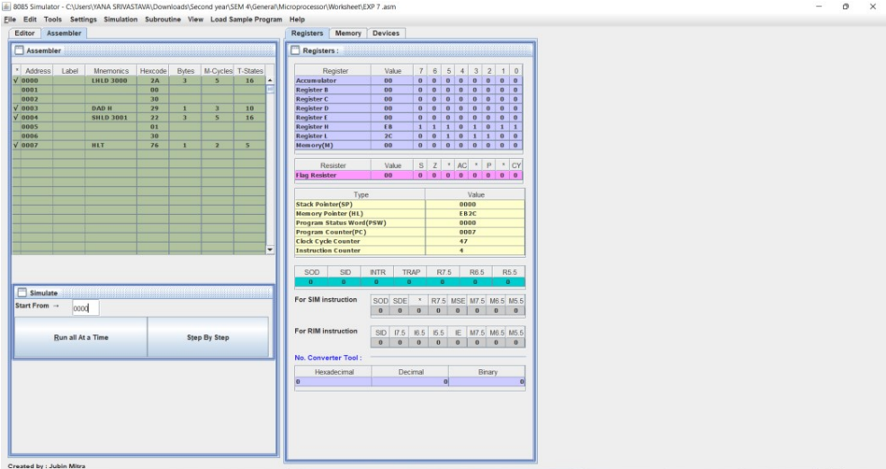

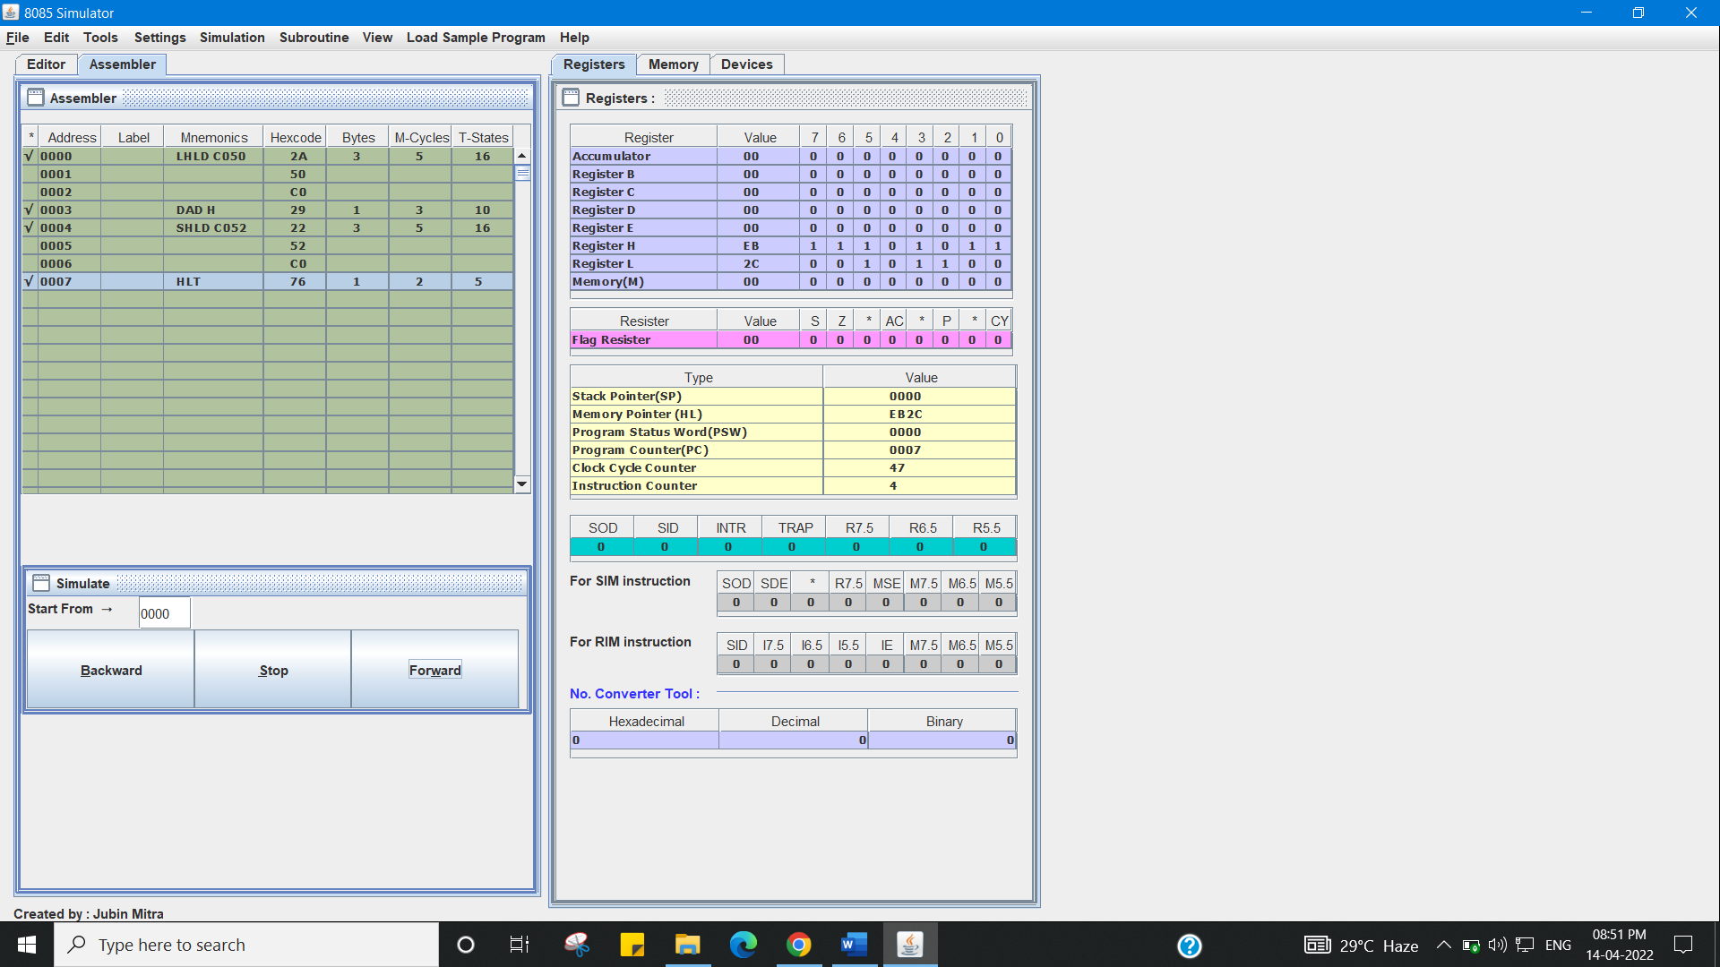

**b) Shift a 16-bit number to left by 2-bits:**

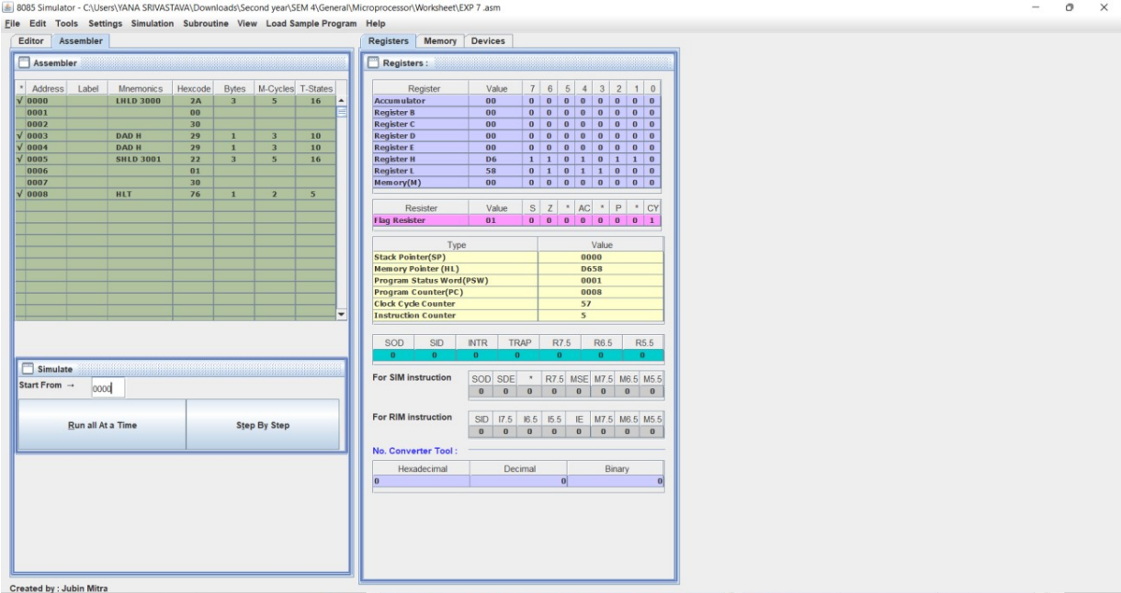

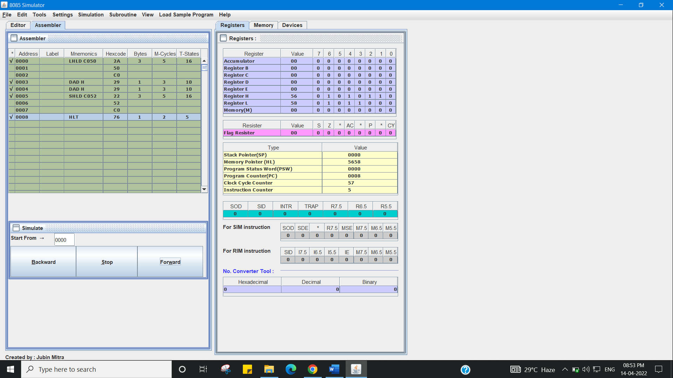

**Learning outcomes (What I have learnt):**

1. Working of microprocessors.

2. Learn how to shift data in microprocessors.

3. Learn about 8085 simulator.

4. Operations of 16-bit numbers.

5. Learn about the different instructions that are needed to be given to the memory to perform some tasks.

**Evaluation Grid (To be created as per the SOP and Assessment guidelines by the faculty):**

|  |  |  |  |
| --- | --- | --- | --- |
| Sr. No. | Parameters | Marks Obtained | Maximum Marks |
| 1. |  |  |  |
| 2. |  |  |  |
| 3. |  |  |  |
|  |  |  |  |